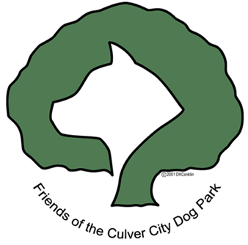
P. O. Box 4129
Culver City CA 90231-4129
310-397-2112-Fax 310-390-9114- Phone
Email: info@culvercitydogpark.org www.culvercitydogpark.org

Dear Supporter:

Friends of the Culver City Dog Park is a non-profit group dedicated to supporting The Boneyard, Culver City’s off leash dog park. The park opened in April 2006, with the support of the community, and we are continuing raising money to add important items such as lights, a retaining wall, pathways, landscaping, irrigation and more.

We offer you an opportunity to enhance and improve the park by supporting our Boneyard Bash 4 Fundraising Dinner on October 18, 2008.

What: Boneyard Bash Dinner/Live Auction/Silent Auction/Opportunity Cash Drawing
$75.00 per person

When: Saturday, October 18, 2008 – 6:30pm Silent Auction; 7:30pm Dinner

Where: Radisson Hotel 6161 Centinela Av, Culver City

Why: To raise funds, enhance & improve "The Boneyard", Culver City’s fenced-in, off-leash dog park located in Culver City Park, south of Jefferson on Duquesne.

How: By attending the event, purchasing an ad, donating auction items, volunteering

Deadlines: For Auction Items: October 8, 2008 For Ads: October 1, 2008

Program Ads: 1/8 page - $40; 1/4 page - $75; 1/2 page - $150; full page - $225; inside back
cover - $400; inside front cover - $400; outside back cover - $750

To donate Silent & Live Auction items, contact Laura Stuart at 310-390-4757 or 310-487-5214 or email at stuartlauraj@hotmail.com

To place an ad, or for program book information, contact info@culvercitydogpark.org; or call 310-390-9114

Mail your ads (camera ready), gift certificates, checks, dinner reservations, and donations to: Friends of the Culver City Dog Park, P O Box 4129, Culver City CA 90231-4129.

We also have a Major Donor Program to adopt items in the park. For further information, visit our website at www.culvercitydogpark.org ; email info@culvercitydogpark.org - or phone Vicki Daly Redholtz, Chair, at 310-390-9114.

Thank you for supporting this very special project.

